**ACE ENGINEERING, GATHKESAR**

***(An Autonomous Institute under JNTU, Hyderabad)***

**DEPARTMENT OF COMPUTER SCIENCE ENGINEERING(IOT)**

**EBOX: PROJECT**

**Presentation**

**on**

# FREELANCER MARKETPLACE

**Connecting Clients and Freelancers Globally**

## Guide:

*MR.KRISHNANAND*

## Presented by :

B. VAMSHI (21AG1A6908)

K. SUSHMITHA (21AG1A6935)

P. MANI GAYATHRI (21AG1A6949)

**CONTENTS:**

* Introduction
* Workflow Overview
* Functional Requirement
* ER Diagram
* Challenges and solutions

# INTRODUCTION

* What is a Freelancer Marketplace?
* An online platform connecting clients with freelancers.
* Facilitates project posting, proposal submission, contract formation, and reviews.
* A freelancer is an independent professional who offers specialized services to clients on a project-by-project basis rather than being employed by a single organization.

**Workflow Overview**

1. **Project Posting**: Client posts a project.
2. **Proposal Submission**: Freelancers submit proposals.
3. **Proposal Review**: Client reviews and selects a proposal.
4. **Contract Formation**: Contract is established.
5. **Project Execution**: Freelancer works on the project.
6. **Payment & Completion**: Payment is released upon completion.
7. **Review & Rating**: Both parties leave reviews.

Functional Requirements for Freelancer Marketplace

# Project Management:

Post projects: Title, description, budget, timeline.

# Proposal Management:

Submit proposals: Bid amount, approach. Review and select proposals.

# Contract Management:

Form contracts: Project details, payment terms. Track contract status.

# Communication Tools:

Built-in messaging.

File attachments and notifications.

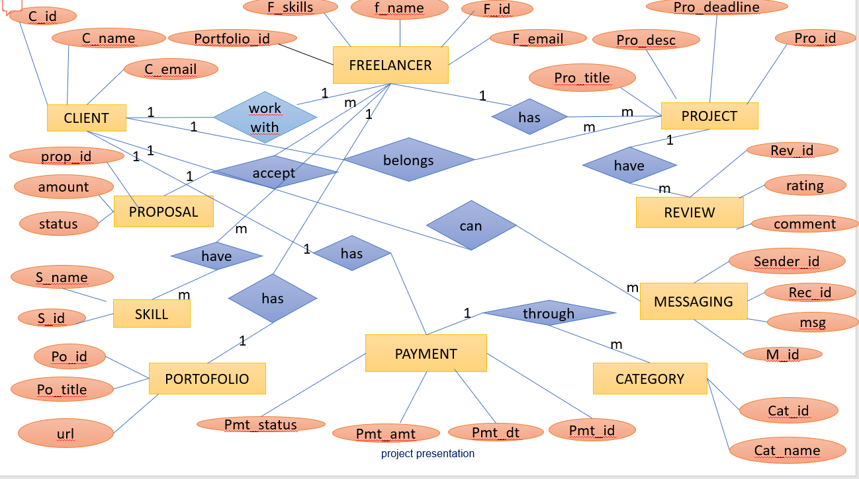

**Challenges and Solutions**

# Challenges:

* + - Miscommunication
    - payment issues
    - quality assurance.

# Solutions:

* + - Clear contracts
    - milestone payments
    - review systems.

**Thank you**